1.
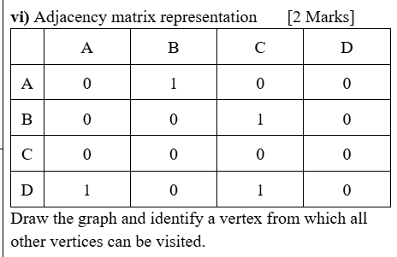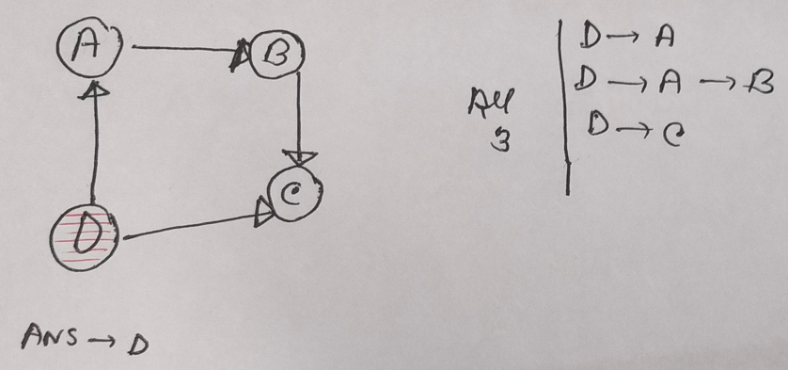

_____________________________________________
2. What is the maximum number of edges in a directed graph with 6 vertices (no self-loops)? [1 Mark] [Medium]
a) 15 b) 36 c) 30 d) 12
Answer: c) 30
Explanation :
- Total vertices: n = 6
- From each vertex, you can connect to (n − 1) = 5 other vertices
- So, total edges: Max edges=n(n−1)=6×5=3
_____________________________________________
3. A directed graph is represented using an adjacency list. If the total number of vertices in full adjacency lists is 15, how many edges are present? [1 Mark] [Medium]
a) 5 b) 10 c) 15 d) Cannot be determined
Answer: d) Cannot be determined
Explanation :In a directed graph,
Number of distinct vertices in the adjacency lists != Number of edges
The same vertex may appear in multiple adjacency lists, so knowing that there are 15 distinct vertices/nodes does not tell us how many edges are present.
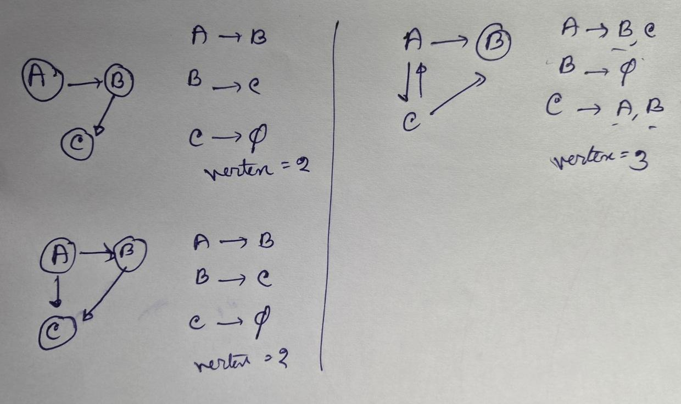
4. An undirected graph (no self loop) has 7 vertices. What is the maximum number of edges it can have?
a) 6 b) 21 c) 14 d) 49
Answer: b) 21
Explanation: Maximum edges in an undirected graph with no self-loop = n(n−1)/2.
For 7 vertices: 7×6/2 = 21. ________________________________________________________
5. A fully connected graph has 9 vertices and 12 edges. By removing how many edges will this graph be a tree? a) 1 b) 2 c) 3 d) 4
Answer: d) 4
Explanation: For a tree, no of edges == no of nodes - 1. A tree with 9 vertices must have 9−1 = 8 edges. The graph has 12 edges, so remove 12−8 = 4 edges.
_____________________________________________
6. In any directed, unweighted graph, the sum of all vertex degrees (in + out) is always even.
True
Explanation: Every edge contributes +1 to in-degree and +1 to out-degree, so the total sum is 2|E|, which is always even.
_____________________________________________
7. In a graph stored as adjacency lists, determining whether edge (u, v) exists takes O(1) time in the worst case.
False
Explanation:It requires traversing the adjacency list of u, which takes O(deg(u)) in the worst case.
_____________________________________________
8. Space complexities of Adjacency Matrix vs Adjacency List (2 marks)
- Adjacency Matrix: O(V²) → needs space for all possible edges, regardless of whether they exist
- Adjacency List: O(V + E) → only stores existing edges.
- Difference: Matrix wastes space in sparse graphs, while List is efficient for sparse graphs.
_____________________________________________

Spring2026 Final
// ================= Approach 1 =================
// Using Net Balance Array
// Time Complexity: O(V + E)
// Space Complexity: O(V)

static void richestVertexApproach1(Edge[] transaction) {

int n = transaction.length;

int[] balance = new int[n];

for (int u = 0; u < n; u++) {

Edge edge = transaction[u];

while (edge != null) {

int v = edge.toVertex;
int w = edge.weight;

balance[u] = balance[u] - w;
balance[v] = balance[v] + w;

edge = edge.next;
}
}

int richest = 0;
int maxBalance = balance[0];

for (int i = 1; i < n; i++) {

if (balance[i] > maxBalance) {
maxBalance = balance[i];
richest = i;
}

else if (balance[i] == maxBalance && i < richest) {
richest = i;
}
}

System.out.println("Account with highest money vertex: " + richest);
System.out.println("Highest net money: " + maxBalance);
}

// ================= Approach 2 =================
// Using Separate Incoming and Outgoing Arrays
// Time Complexity: O(V + E)
// Space Complexity: O(V)

static void richestVertexApproach2(Edge[] transaction) {

int n = transaction.length;

int[] incoming = new int[n];
int[] outgoing = new int[n];

for (int u = 0; u < n; u++) {

Edge edge = transaction[u];

while (edge != null) {

int v = edge.toVertex;
int w = edge.weight;

outgoing[u] = outgoing[u] + w;
incoming[v] = incoming[v] + w;

edge = edge.next;
}
}

int richest = 0;
int maxBalance = incoming[0] - outgoing[0];

for (int i = 1; i < n; i++) {

int net = incoming[i] - outgoing[i];

if (net > maxBalance) {
maxBalance = net;
richest = i;
}

else if (net == maxBalance && i < richest) {
richest = i;
}
}

System.out.println("Account with highest money vertex: " + richest);
System.out.println("Highest net money: " + maxBalance);
}

// ================= Approach 3 =================
// Brute Force Method
// Time Complexity: O(V * (V + E))
// Space Complexity: O(1)

static void richestVertexApproach3(Edge[] transaction) {

int n = transaction.length;

int richest = 0;
int maxBalance = Integer.MIN_VALUE;

for (int x = 0; x < n; x++) {

int incoming = 0;
int outgoing = 0;

for (int u = 0; u < n; u++) {

Edge edge = transaction[u];

while (edge != null) {

int v = edge.toVertex;
int w = edge.weight;

if (u == x) {
outgoing = outgoing + w;
}

if (v == x) {
incoming = incoming + w;
}

edge = edge.next;
}
}

int net = incoming - outgoing;

if (net > maxBalance) {
maxBalance = net;
richest = x;
}

else if (net == maxBalance && x < richest) {
richest = x;
}
}

System.out.println("Account with highest money vertex: " + richest);
System.out.println("Highest net money: " + maxBalance);
}

FALL2025
// =========================
// Style 1 (Efficient)
// =========================
// - Computes in-degree and out-degree in ONE traversal of adjacency list
// - Time Complexity: O(V + E) → more efficient

static int[][] networkCheck1(Edge[] network) {
int n = network.length; // number of vertices

int[][] deg = new int[n][2];

for (int i = 0; i < n; i++) {
deg[i][0] = 0;
deg[i][1] = 0; // [in-degree, out-degree]
}

// Single traversal of adjacency list
for (int u = 0; u < n; u++) {
Edge cur = network[u];
while (cur != null) {
int v = cur.destination;
deg[u][1] += 1; // increment out-degree of u
deg[v][0] += 1; // increment in-degree of v
cur = cur.next;
}
}

int in0 = deg[0][0]; // reference in-degree
int out0 = deg[0][1]; // reference out-degree

boolean regular = true;
// Check if all vertices have same in/out degree
for (int i = 1; i < n; i++) {
if (deg[i][0] != in0 || deg[i][1] != out0) {
regular = false;
break;
}
}

// Output result
if (regular) {
System.out.println("Regular graph (Style 1)");
} else {
System.out.println("Not regular graph (Style 1)");
}

return deg;
}

// =========================
// Method 2 (Less Efficient)
// =========================
// - Uses separate helper functions (in_degree, out_degree)
// - in_degree scans the whole graph for each vertex
// - Time Complexity: O(V * (V + E)) → less efficient

// Counts outgoing edges of vertex v
static int out_degree(Edge[] network, int v) {
int count = 0;
Edge e = network[v];
while (e != null) {
count += 1;
e = e.next;
}
return count;
}

// Counts incoming edges of vertex v (scans entire graph)
static int in_degree(Edge[] network, int v) {
int count = 0;
for (int i = 0; i < network.length; i++) {
Edge e = network[i];
while (e != null) {
if (e.destination == v) {
count += 1;
}
e = e.next;
}
}
return count;
}

// =========================
// Style 2 (Less Efficient)
// =========================
// - Uses helper functions → repeated traversal → O(V * (V + E))

static int[][] NetworkCheck2(Edge[] network) {
int n = network.length; // number of vertices

int[][] arr2D = new int[n][2];

for (int i = 0; i < n; i++) {
arr2D[i][0] = 0;
arr2D[i][1] = 0; // [in-degree, out-degree]
}

// Compute degrees using helper functions
for (int i = 0; i < n; i++) {
arr2D[i][0] = in_degree(network, i); // in-degree
arr2D[i][1] = out_degree(network, i); // out-degree
}

int ref_in = arr2D[0][0]; // reference in-degree
int ref_out = arr2D[0][1]; // reference out-degree

boolean regular = true;
// Check if all vertices match reference degrees
for (int i = 1; i < n; i++) {
if (arr2D[i][0] != ref_in || arr2D[i][1] != ref_out) {
regular = false;
break;
}
}

// Output result
if (regular) {
System.out.println("Regular graph (Style 2)");
} else {
System.out.println("Not regular graph (Style 2)");
}

return arr2D;
}

Summer2025
public static void maxMutual(int[][] graph, String[] mapper) {
int numPeople = graph.length; // total number of vertices (people)
int maxMutualCount = 0; // highest number of mutual friends found
int person1Index = -1; // store index of first person in best pair
int person2Index = -1; // store index of second person in best pair

// Iterate through all unique pairs of people (i < j to avoid duplicates)
for (int personA = 0; personA < numPeople; personA++) {
for (int personB = personA + 1; personB < numPeople; personB++) {
int mutualCount = 0; // reset counter for this pair

// Check every other person to see if they are a mutual friend
for (int friend = 0; friend < numPeople; friend++) {
// Conditions:
// 1. friend should not be the same as personA or personB
// 2. friend must be directly connected to both personA and personB
if (friend != personA && friend != personB
&& graph[personA][friend] == 1
&& graph[personB][friend] == 1) {
mutualCount++;
}
}

// Update best pair if this pair has more mutual friends
if (mutualCount > maxMutualCount) {
maxMutualCount = mutualCount;
person1Index = personA;
person2Index = personB;
}
}
}

// Final output based on whether a valid pair was found
if (person1Index == -1 || maxMutualCount == 0) {
System.out.println("There are no mutual friends between any vertices.");
} else {
System.out.println(mapper[person1Index] + " and " + mapper[person2Index]
+ " have " + maxMutualCount + " mutual friend(s).");
}
}

